
A TM Systems© Company

© All Rights Reserved
TABLE OF CONTENTS

The Kitchen – A TM Systems Company 3
Dubbing Script Principles 3
1 – FORMATTING 4
Page Set Up 4
Font and Spacing 4
Saving the Document 6
Header 6
Dialogue Length 8
First Line Formatting 10
2 – TRANSLATION AND ADAPTATION 11
Translation 11
Conversions 12
Language Style 13
Adaptation 14
Lip-sync Adaptation Technique 14
Voice Over Adaptation Technique 15
Narrator Voice Over 15
Gender Voice Over 16
Character Allocation 17
Glossary 19
Characters Names Formatting/Spelling 20
Allocating Crowd 20
Allocating Characters Speaking at the Same Time 21
Allocating Spirits, Animals, Mimics, Background Dialogues 21
Voice Over Character Allocation 23
Allocating Character for Graphics 23
Songs 24
3 – PAUSES AND REACTIONS 25
Pauses 25
Reactions 26
4 – SPOTTING 30
Reading Time Codes 30
Segmentation 31

Spotting 32
Overlapping Time Codes 33
Two Lines Dialogue Rule 36
Spotting Crowds 36
5 – REVISION 38
6 – LINE COUNT 39
7 – TRANSTATION™ BASIC COMMANDS 42
Knowing TranStation™ 42
Setting Up TranStation™ for Dubbing 42
Spotting Commands - Enter/Space Bar 44
Simulation Command - Control + L 44

THE KITCHEN - A TM SYSTEMS COMPANY

The Kitchen, located in Los Angeles, Miami and Caracas, is one of the leading Dubbing, Subtitling and Closed Captioning companies in the world with a full service approach to global language services.
The Kitchen services are built around the entertainment industry’s only EMMY® Award winning technology for “end to end” language customization solutions. These tools streamline the entire process from translation through dubbing, subtitling and closed captioning.

For more information, visit our website www.thekitchen.tv.

DUBBING SCRIPT PRINCIPLES

DUBbing is the process of recording or replacing original voices on a feature film or television show, with voices in the target language.

It can be done using lip-sync, which is a technical term for matching lip movements with voice. Or voice over commonly referred to as "off camera" dialogues, usually done by a Narrator. *

Most of The Kitchen projects use lip-sync techniques, where adaptation is essential to achieving a well written script.

When you're working on a dubbing project, keep in mind that what you're writing will be interpreted by a voice talent, and not read by an audience (as in subtitling).

There are four core elements in a dubbing script: Formatting, Translation/Adaptation, Insertion of Pauses and Reactions, and Spotting. The Kitchen has set guidelines for those elements, in order to keep the consistency among all our projects and to help you deliver a well adapted script for dubbing.

When the script is done, the next step in the chain is the recording. Each voice talent records their respective voices/characters separately, and therefore, it’s important that each character’s dialogue in the script is treated as an individual script in itself.

Those recorded dialogues are then put together in the mixing step of this process along with the M&E (music and effects). Then the show is ready to be QC’ed (our Quality Control team makes sure each episode/show is complete and in compliance with our standards), shipped to the client for final approval and, finally, to be aired.

*Excerpt from Wikipedia.com

1 - FORMATTING

Open the WORD software to start working on a blank document. You can also open the original script and work on that only if it’s in WORD.

Now, you’ll work on:

Page Set up

The document should always be in portrait orientation with the margins set as follows:

TOP: 1”
BOTTOM: 1”
LEFT: 1.25”
RIGHT: 1.25”

Font and Spacing

Use Font Courier New, size 12.
Make sure paragraph is set to single spacing.

No tabs or indentation whatsoever.

Attention: if you’re working on the original script sent to you by The Kitchen, make sure there are no tab marks in the document, by clicking on the show/hide icon to see those. Tab marks are shown as arrows in the picture below (sometimes they appear as down/left arrows).

When you click on the show/hide icon, you’ll also be able to see any hidden formatting. Make sure all you see in spacing is the ENTER mark (the one at the end of each line in the picture below).

It’s crucial that the final dubbing script has NO EXTRA SPACE/FORMATTING other than the specified in this manual.

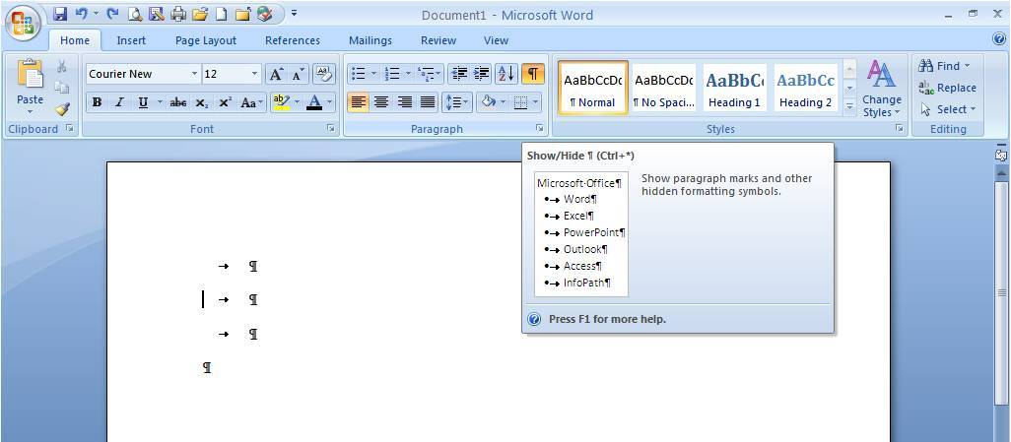
If you find tabs marks, please copy the space where the arrow is, then press Ctrl+C:

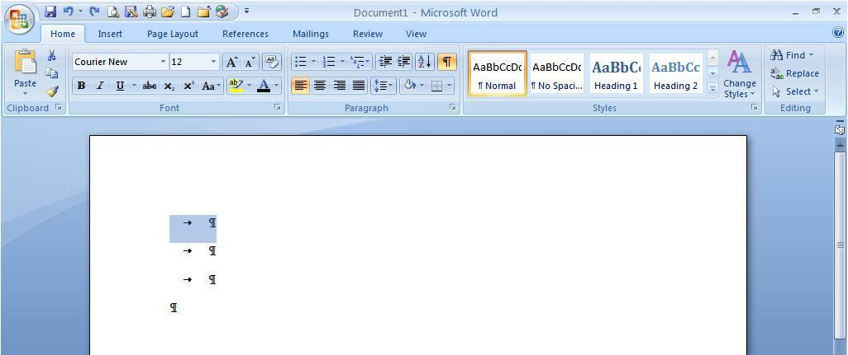

Press Ctrl+H and you’ll see the find and replace window:

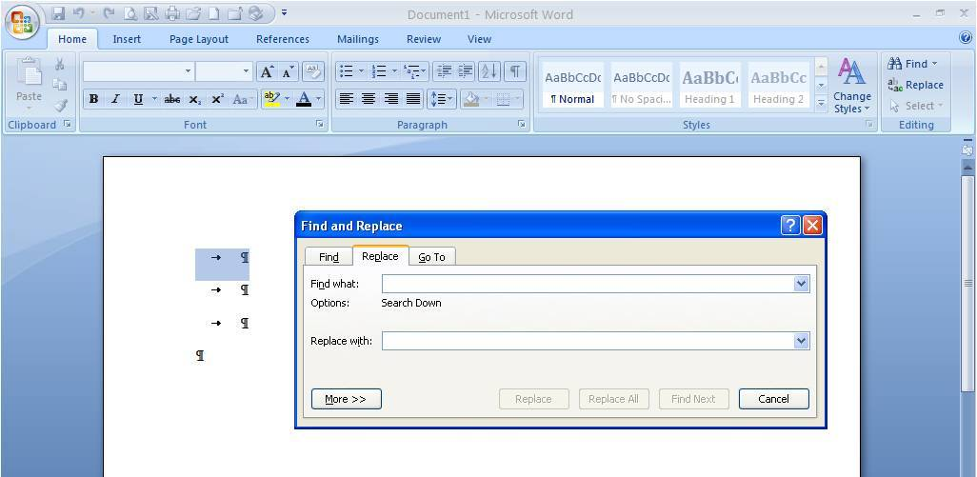

Put the cursor in the Find what box and press Ctrl+V (to paste the tab – you won’t see anything in that box, but the tab mark is there). Ignore the Replace with box, and then click on Replace All. Keep clicking on Replace All until you see a window with the message “... has made 0 replacements.”

For double spaces (within the dialogues), in the Find what box press the space bar twice (you won’t see anything, but the double space is there), on the Replace with box press the space bar once, then click on Replace All. Keep clicking on Replace All until you see a window with the message “... has made 0 replacements.”

For extra space at the end of a dialogue or after the character’s name, on Find what box write:

(space)^p – space means to press the space bar once not to write the word space in between parentheses.

In the Replace with box, write:
^p – without the space at the beginning.

Click on Replace All. Keep clicking on Replace All until you see a window with the message “... has made 0 replacements.”

Saving the document

At this point, save the document with the exact name furnished to you on the PO (Purchase Order) sent to you by The Kitchen. Save it as Word 97-2003 (.doc)

Header

On the Insert tab, click on Header. (The procedure now will vary according to the WORD version you have, so we’ll go directly to the principle of inserting the file name in the header portion of the document).

In the Header field click on the option insert field.

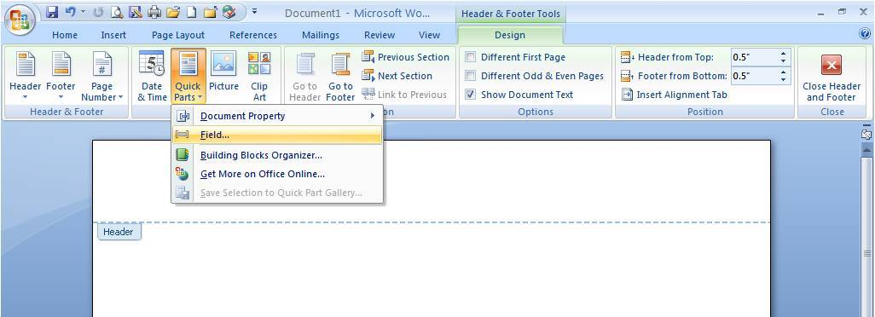

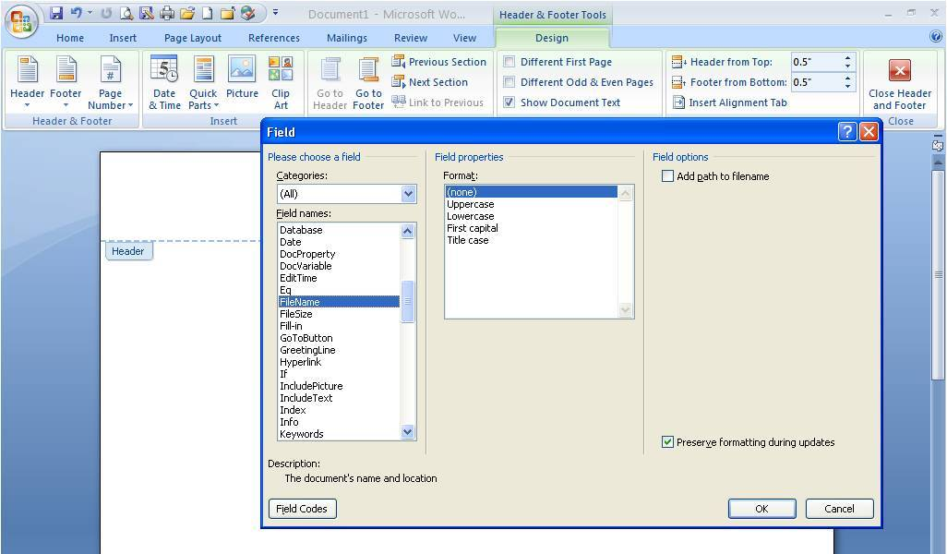

Choose the option filename.
WORD will automatically insert the file name in the header of your document.

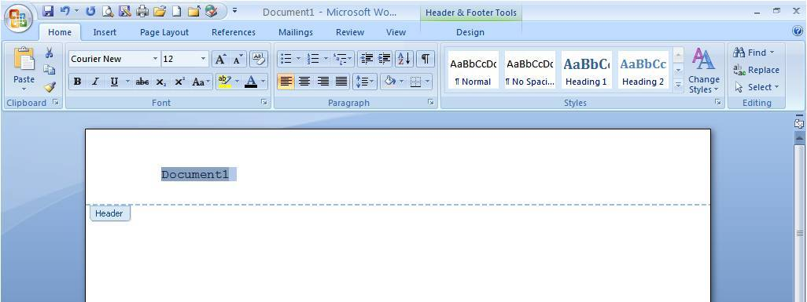

After the file name is inserted, make sure you format that into Courier New font, size 12.

Dialogue Length

At this point, you’re ready to begin translating/adapting. As you do so, pay attention to the number of lines per dialogue.

Dialogues can never have more than TWO (2) lines and need to be on full sentences ending with a punctuation mark; period, ellipsis, question mark, etc.

CORRECT NUMBER OF LINES IN A DIALOGUE

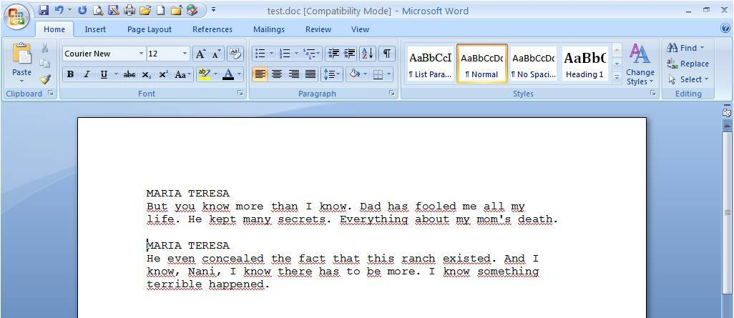

WRONG NUMBER OF LINES IN A DIALOGUE

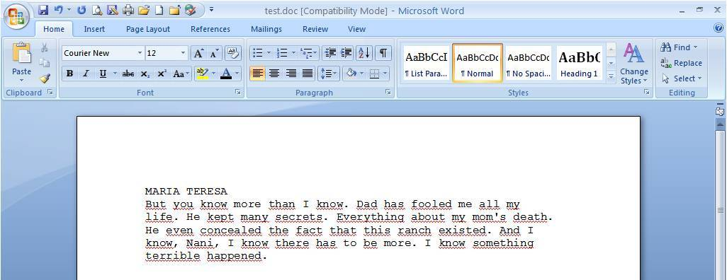

Make sure you have a blank line between dialogues. This line is created by pressing ENTER twice at the end of each dialogue. DO NOT press ENTER in the middle of a dialogue.

CORRECT SPACING BETWEEN DIALOGUES

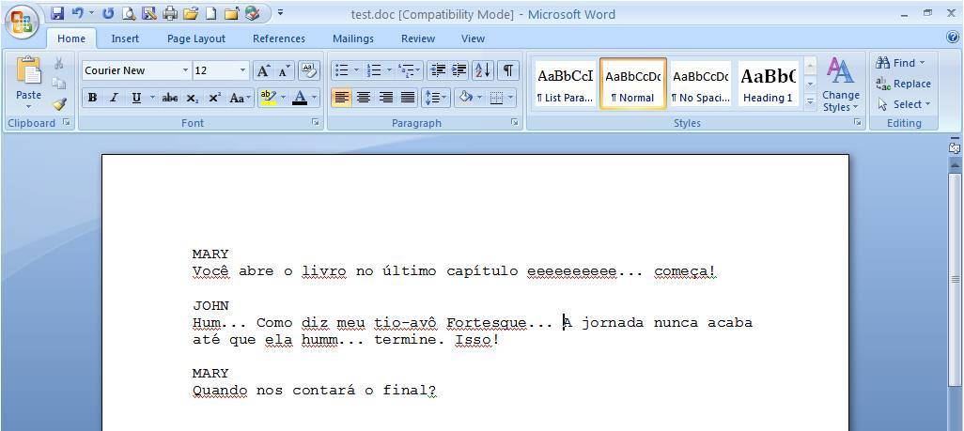

WRONG SPACING BETWEEN DIALOGUES

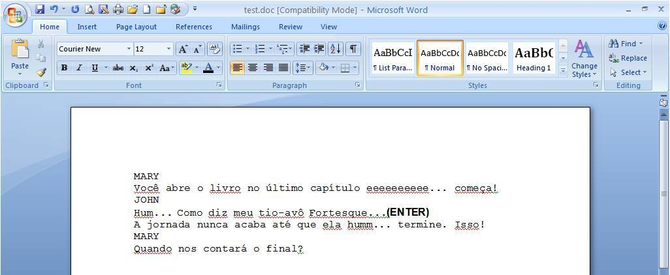

First Line Formatting

Because the first line in a dubbing script is the character name in UPPER CASE, sometimes WORD automatically sets the formatting of that first line as ALL CAPS (see picture below).

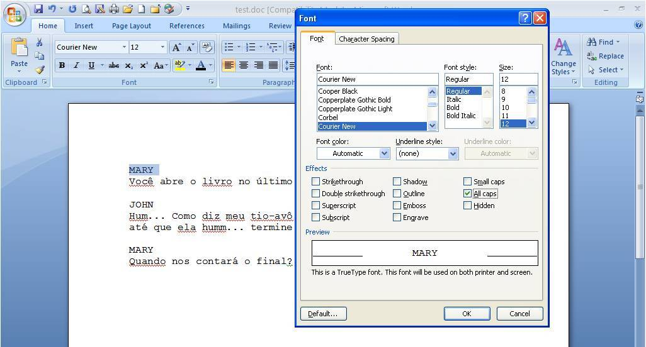

At some point in the beginning of the translation/adaptation process, go back to that first line, highlight it, click on font and make sure the option ALL CAPS is not checked.

Not following this procedure will affect the line count later on.

CORRECT FIRST LINE FORMAT

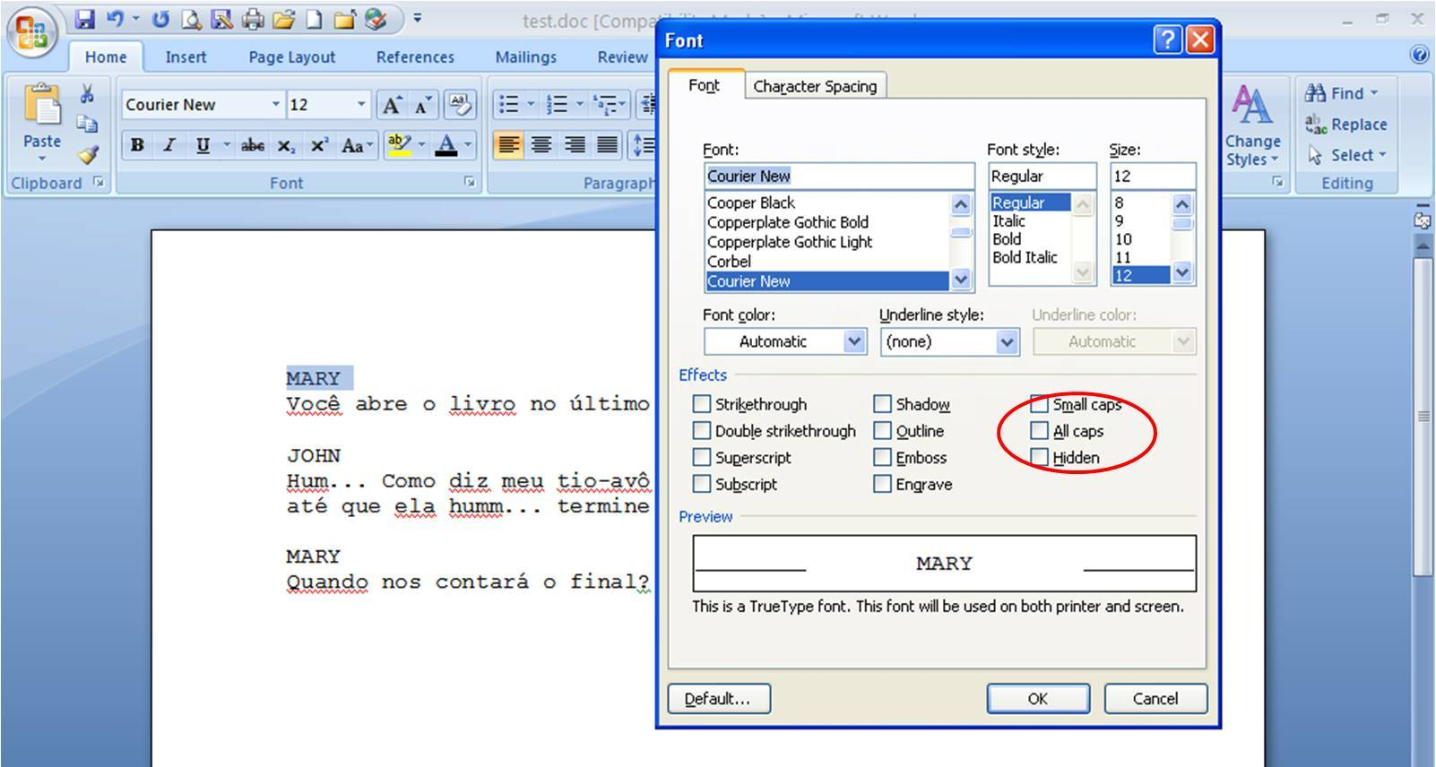

2 - TRANSLATION AND ADAPTATION

Translation

This is the foundation of a proper dubbing script. At this point, you need to write in the target language what is semantically (NEVER literally) being said on the original language.

To translate is to write in the target language the exact same semantic meaning of what’s being said in the original language.

Excerpt from Random House Webster’s Dictionary:
se·man·tics (si manÆtiks)
1. Ling.
a. the study of meaning.
b. the study of linguistic development by classifying and examining changes in meaning and form.
3. the meaning, or an interpretation of the meaning, of a word, sign, sentence, etc.

Original dialogue:
Coroner: There are lots of sick people in this world.
Detective: You can say that again.

“You can say that again” is an idiomatic expression that means I agree with you. Translating that sentence literally to any target language is doing a wrong translation.

Semantic meaning to be translated into the target language:
CORONER
There are lots of sick people in this world.

DETECTIVE
I agree with you.

Wrong translation:
CORONER
There are lots of sick people in this world.

DETECTIVE
Repeat that.

It clearly does not convey the original message. For this reason we never work with literal translation. Literal translation is a translation done incorrectly.

Another important thing for lip-sync purpose is that you spell numbers, currencies, and measurements.

CORRECT
She paid forty-five dollars for that dress.
Conversions

Conversion is required in the following cases:

Mass - Libras / Kilos
Length - Feet / Meters
Inches / Centimeters
Miles / Kilometers
Temperature - Fahrenheit / Celsius
Volume - Gallon / Liter

There are cases where the precision of a conversion won’t be necessary.

Within 1.5 km on the road she had to use the restroom.
( 1 mile = 1,61 km)

She lost almost 4 liters of blood.
(1 gallon = 3,79 liters)

But there will also be cases where the precision is a must. In a reality show like The Biggest Loser, measurements must be precisely converted as the winner takes the prize.

We’re on the fourth week and she only lost 4,54 kilos.
(10 libras = 4,54 kilos)

Use common sense to determine when the decimals are necessary and never forget to use the correct punctuation for each of the systems.

Clothing and shoe sizes are also to be converted.

Hours are converted as follows:

English  Hours: 8 am 10:30pm  Minutes: min. | Spanish  Horas: 8 a.m. 10:30 p.m.  Minutos: min. | Portuguese (24-hour format)  Hora: 21h35  Minutos: min.

Currency is never converted or atualized.

In a 1954 movie, a woman wins a huge prize in Money in the sum of 1,000 dollars. The sound bite is:

She won 1,000 dollars.

The translation will be, regardless the target language:

Ella ganó 1,000 dólares.
Ela ganhou 1,000 dólares.
Language Style

Translating is writing in the target language the exact message contained in the original language. You can write that in several different ways, but in one determined style.

The style of each project will be communicated to you as soon as the PO and assets are delivered to you.

Usually our dubbing scripts are written in a colloquial style. Keep in mind that in dubbing, your translation will be read by various voice talent who will interpret and convey the emotions shown on-camera by the original actors, so your translation will be heard by the audience.

There are certain projects where the style may vary. It can be formal, poetic and so forth. If there is no determination as to which language style to use, always apply the colloquial style (spoken language).

Regardless of the style however, The Kitchen never uses the following in any of its translations, unless otherwise requested by the client. They are:
- Slang;
- Regional expressions;
- Vulgar words.

Slang is determined by the times. A slang created today, may not be part of the vocabulary in 20 years. A slang used 20 years ago might sound funny if used in a translation done nowadays. In order to keep our projects fresh and timeless, we avoid the use of slang.

Regional expressions are terms used by a certain group of people within that country or region. An expression or word used in the North of Brazil might not be understood in the South of Brazil, or it can be understood, but by using that expression you’re determining that the character who says that is from that region of the country (North). If that was not the author’s initial intention (to determine different backgrounds within the characters), then the translation is creating an element that originally doesn’t exist and therefore, is wrong.

On the other hand, a typical expression in England might not be understood in the US, or an expression common in Portugal might not be understood in Brazil, or a southern expression in Spain might not be understood in the South American countries. Even if those expressions can be understood in other countries/cities, by using regional expressions you’re either determining that the character is from that specific region or that the character talks like people from that specific region, which if not established in the original script, makes your translation incorrect.

Vulgar, offensive words are not regularly used.

It can be the dirtiest of the movies, whenever a vulgar, offensive word is spoken, you must find a similar less vulgar and less offensive word during translation. Here are some examples done in English and such variation can be found in any target language, regardless of the language:

Take that shit out of there.
Take that crap out of there.

Fuck you.
Go to hell.

That faggot hit my car.
That idiot hit my car.

That whitey will get what he deserves.
That bastard will get what he deserves.

But whitey refers to race and bastard to birth, isn’t it wrong?

No. First the audience is seeing that the guy is white, so no need to point that out. Secondly, whitey is an offensive and disparaging word, and the use of this word in that dialogue is to show the hate from the character who said it. Bastard will do the same and the adaptation won’t suffer either (which would happen if instead of whitey you chose the words white man). But if it’s a documentary about racism, then we use white man, black man, still avoiding the vulgar, offensive wording, unless otherwise instructed.

Also, regardless of the style, we always write grammatically and orthographically correct.

Adaptation

As you translate each dialogue, the choice of words must match the same amount of time that the original actors/narrator took to say their lines.

Adaptation can be done for lip-sync or voice over.

This information can be found in the instructions portion of the Purchase Order (PO).
Translate/adapt accordingly. It’s crucial that you pay attention to that specification in the PO as the techniques involved in each format are quite different.

Lip-Sync Adaptation Technique

Adapting a script for LIP-SYNC is to synthesize or expand the dialogue in the target language, in order to match the original actor’s lip movement. The voice talent should be able to read and interpret each dialogue, moving his/her lips in similar motion as the original actor’s.

The translation done needs to match the amount of syllables, as close as possible, that the original language has.

For example, let’s say the scene is a Japanese character saying:
Watoo lapah! Watoo lapah!

Which would mean: Get out of here now! Get out of here now!

The adaptation for dubbing would be:
Get out now! Get out now!

It wouldn’t be well adapted if the paragraph read:

Get out of here now! Get out of here now!
(too many syllables to match the original)
or

Get out of here! Get out of here!
(still too many syllables to match the original)
or

Out! Out!
(too few syllables to match the original)
or

Get out! Get out!
(still too few syllables to match the original)

Exercise: say out loud - Watoo lapah! Watoo lapah!, then say out loud all four ways of translating/adapting this original audio.

(Note: watoo lapah means nothing (I hope) in Japanese, I just used the phonetic to help you understand the point about language adaptation).

You can easily do this exercise while reviewing the dialogues. Read out loud what you wrote against the original audio.

If you have to say the dialogue in one breath/quickly to match the audio and actor’s lip movement, the dialogue is too long, you’ll need to shorten it.

If you finish saying the dialogue and the audio is still ongoing and obviously the actor is still moving his/her lips, the dialogue is too short, you’ll need to make it longer.

Voice Over Adaptation Technique

There are two types of Voice Over dubbing scripts:

NARRATOR VOICE OVER

If there is an OFF-CAMERA Narrator telling the original story, there will be an OFF-CAMERA Narrator telling the story in the target language. The translation is done correctly with no insertions or deletion from the original text, and adaptation is not required as it is in a lip-sync script.

There’s no need to observe syllable count in the dialogues, even though the length of each dialogue must match the original’s.

Original Narrator: Der Eisbär, wissenschaftlichen Namen Ursus maritimus, ist ein Bär native weitgehend innerhalb des Polarkreises umfasst den Arktischen Ozean, den angrenzenden Seegebieten und die umliegenden Landmassen.

Translation/Adaptation:
MALE NARRATOR
The polar bear, scientific name Ursus maritimus, is a bear native largely within the Arctic circle encompassing the Arctic Ocean, its surrounding seas and surrounding land masses.

The German version is a little longer than the English version, but that’s not a problem because the Narrator is off-camera. The translation is done correctly, the original message is present in the dialogue and no adaptation is necessary.

Examples of wrong VO adaptation:

Too short:
MALE NARRATOR
The polar bear is native within the Arctic circle encompassing the Arctic Ocean, its surrounding seas and surrounding lands.

Or too long:
MALE NARRATOR
The polar bear, scientific name Ursus maritimus, is the world's largest carnivore species found on land, and is a native largely within the Arctic circle encompassing the Arctic Ocean, its surrounding seas and surrounding land masses.

GENDER VOICE OVER

This is when the voice talent record what the original characters are saying on- or off-camera, as if it was a live translation. In translation/adaptation for Voice Over, the speech is never in the third person. Pronouns are translated literally.

Robert: Paul and I will travel the world.

WRONG TRANSLATION
MALE VO
Paul and Robert will travel the world.

Even though in Voice Over scripts, lip-sync is not to be observed, dialogues must be adapted to be slightly shorter than the original, because the Voice Over starts a little after the original sound bite and will end a little before the sound bite ends. (More detailed explanation in regards to timing in the Spotting section of this Manual.)

Now that the WORD document is formatted and you know which language style and adaptation technique to apply to the file, you’ll start translating/adapting the script for dubbing in the target language.

Here is one important element to consider when translating/adapting the dubbing script.

Character Allocation

As it was said in the introduction, each voice talent records his/her character individually. So when a voice talent is recording, he/she will only see the dialogues belonging to his/her character (on the picture below the voice talent is recording Ricardo’s dialogues only).

Let’s say we’re dubbing the animated feature Shrek and Mike Myers is at The Kitchen’s studio ready to record Shrek’s dialogues, already imported to the recording program. (At The Kitchen, the voice talent doesn’t read their dialogues the old-fashioned way, from paper. The recording process at The Kitchen is automated, dialogue copy and video are on one screen. See picture below.

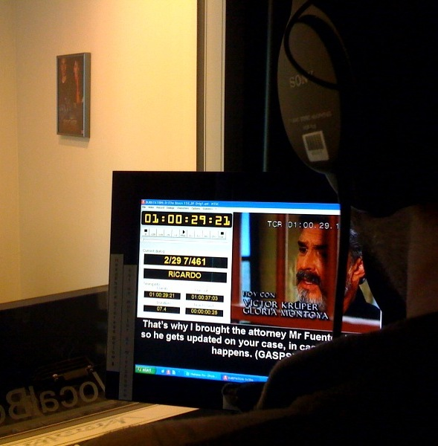
© Voice Talent in a recording session at one of The Kitchen studios.

Unfortunately, the translator made a mistake in the character allocation, by allocating Donkey on one of Shrek’s dialogues. That dialogue set for Donkey won’t be imported to the recording program used in Mr. Myers recording, seeing that he’s recording the dialogues belonging to Shrek only.

On the next day, Eddie Murphy comes in to record Donkey’s dialogues. As the Artistic Director is recording Mr. Murphy’s voice, they find out that there is a dialogue allocated to Donkey that belongs to Shrek.

By now, Mike Myers is in China shooting his new movie and will be back in the US in four months, but Shrek’s dubbed version is set to air in six weeks.

This story serves to illustrate how important Character Allocation is. What might look like a simple mistake regarding character allocation can cost money, time and seriously jeopardize the flow and quality of any project.

You can make sure characters were allocated correctly during the translation process, during the adaptation adjustment, during the insertion of pauses and reactions and/or during the last revision before sending the file in. There are several opportunities to make sure that the correct character was allocated to each dialogue.

You can do that by looking at the script (WORD) or at the TranStation™ window. Whenever a dialogue is running in TranStation™, you’ll see on the window’s bottom right the name of the character to whom that dialogue was allocated to. This way you can follow the dialogue and make sure the character is correct.

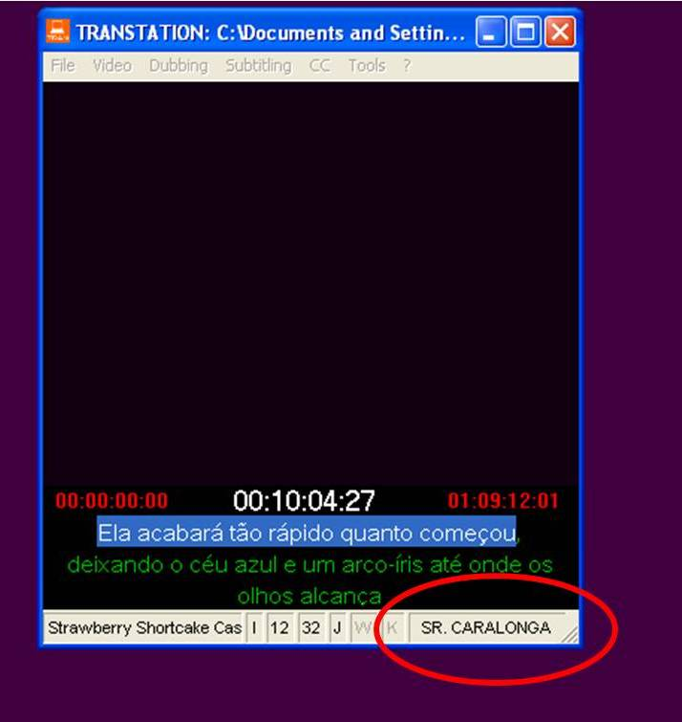

Glossary

Characters names will be provided for each project in a glossary (for long term projects such as soap operas or series) or in the original script (for a single feature such as movies or documentaries, for example).

In long term projects, an initial glossary will be sent to you along with all the assets and this glossary will be updated as the work progresses.

This updating is done every time a new character appears in the show. If you’re working on an episode and notice that a new character is now part of the show, you must immediately send the information to our Translation Department. You should furnish the character’s name and a brief description (physical {tall, fat} and situational {May’s cousin, John’s lover}).

The glossary will be updated and sent to all translators working on that project. There is no other way to identify new characters and your input is crucial to keep the glossary updated and the consistency among all translators/episodes.

There might be some Undetermined Characters during the course of a project (usually represented by extras – not well known actors). Those are assigned according to the gender and position on the story and are not listed in the glossary.

Never allocate a character only by their role in the story, as it’s important for the casting selection to know if those dialogues are spoken by a male or a female artist. Here’s how to allocate those characters:

MALE RECEPTIONIST 1
FEMALE RECEPTIONIST 1
MALE ICE CREAM VENDOR
FEMALE MAID

There might be more than one undetermined character’s gender per script. To differentiate those we use numbers following the gender. No need to allocate MAN IN CROWD, a number after the gender is enough. Examples below:

MAN 1
MAN 2
MAN 3
WOMAN 1
WOMAN 2
WOMAN 3
FEMALE KID 1
FEMALE KID 2
MALE KID 1
MALE KID 2

Characters names formatting/spelling

The characters names are always in CAPS and they must be spelled correctly in every single instance they appear, otherwise the program will recognize each spelling as a different character. Extra space or lack of thereof also falls in this category.

MARIA TERESA
MARIATERESA
MARIA TEREZA
MARIA TERESA(space)

are four different characters.

The same applies to:

MAN 1
MAN1

There must be no space after the character’s name. After writing the character’s name, press ENTER to move to the next line and start translating that character’s dialogue. Press ENTER again only when the dialogue is finished.

MARIA TERESA(ENTER)
Good morning, Dad. Already up?(ENTER)

ALLOCATING CROWDs

When you start translating a scene that you notice there is a crowd (extras) in the background, stop allocating characters to that scene when the crowd audio starts, allocate the crowd as follows:

Crowd dialogues are always (AD LIB).

CROWD
(AD LIB)

If during a CROWD audio you can single out dialogues, before continuing allocating characters and translating/adapting their dialogues in the scene, go back to the beginning of the CROWD audio and start opening dialogues for those characters, as follows:

CROWD
(AD LIB)

MARY
Good morning.

JOHN
Hello! How are you?
When the CROWD is over, continue allocating characters and translating/adapting their dialogues until there is another CROWD on the scene. Proceed as in the above explanation until the end of the scene.

MOTHER
Have you seen Mary?

FATHER
I think she’s with John on the other side of the stage.

CROWD
(AD LIB)

MARY
John, I can’t hear you. This crowd is too noisy.

JOHN
Let’s move over there.

ALLOCATING CHARACTERS SPEAKING AT THE SAME TIME

If more than one character is speaking at the same time, as in a fight for example, open dialogues for each of the characters as usual. The fact that they’re speaking at the same time doesn’t change the fact that they’re speaking and a dialogue must be open.

PAUL
I’ll put my fist to your face!

RICHARD
Not if I put mine to yours first. You bastard.

PAUL
I’ll kill you!

ALLOCATING SPIRITS, ANIMALS, MIMICS, BACKGROUND DIALOGUES

A character called John is possessed by someone else’s spirit and as the spirit he talks. What is the correct character allocation? John or Male Spirit?

Who opens the mouth to say those words? It’s John, right? So the correct character allocation is John. No need to write any indication that he’s talking as the Spirit, as the Artistic Director and the voice talent listen to the audio and follow the character’s story they’ll know that John will say that dialogue with a different voice intonation. It’s an acting direction matter, and does not belong to a dubbing script.

On the other hand, if John fades into the Spirit's image (who is another actor), then a dialogue for GENDER SPIRIT must be open.

MALE SPIRIT
I came to give you a message from your husband.

The same applies when a character is barking, or meowing, or making any animal noise. Animals are not characters. No need to open a dialogue for a dog, for example.

WRONG
DOG
(BARKS)

It’s M&E (music and effects).

As far a background dialogues, they always need to be translated/adapted. Those are dialogues coming from radios, TV sets, public speakers and so forth.

The character allocation in those dialogues follows the same procedure as in undetermined characters. You must determine gender, and where the voice is coming from. Even if what is being said in the background has nothing to do with the content of the show, that dialogue must be open and translated/adapted accordingly:

MALE NEWS ANCHOR
Good evening. Tonight, the police arrested...

TV SHOW HOSTESS
Hello, everyone!

RADIO HOST
This is WGKL-33

FEMALE SPEAKERS VOICE
All citizens must attend the City Council meeting at the City Hall this evening.

VOICE OVER CHARACTER ALLOCATION

In dubbing script for VO, character allocation is as follows:

Off-camera Narrator:
MALE NARRATOR
FEMALE NARRATOR

Voice Over:
MALE VO
FEMALE VO

Same Male VO will cover all actors’ dialogues and same Female VO will cover all actresses’ dialogues, on and off camera.

The client might request that each of the original characters is dubbed in a different voice. In that case, character allocation can either be the same as above with numbers following the name or the character’s name:

MALE VO 1
MALE VO 2
MALE VO 3
FEMALE VO 1
FEMALE VO 2
FEMALE VO 3
PAUL
MARK
RICHARD
ANNA
KATHY
JOANNA

Sometimes characters have two simultaneously occurring dialogues, one as a VO narration, and the second, a dialogue in the background. In these cases the VO narration must have a special allocation:

ACEROLA ACEROLA VO
LARA LARA VO
MONICA MONICA VO
RONALDO RONALDO VO

CHARACTER ALLOCATIon FOR GRAPHICS

Dialogues must be open for on screen graphics, whenever they are not being changed to a localized graphic (a graphic in the target language). We might not have this information until the mixing step of the dubbing process. To avoid missing dialogues, always open dialogues for graphics.

Assign graphic dialogues to a Graphic Narrator character and translate the graphic, as in the example below. The text needs to be ALL IN CAPS.

It’s a cartoon and the rabbit character stops in front of a sign on the side of the road that reads Detour.

GRAPHIC NARRATOR
DETOUR

It’s important to establish that it’s a GRAPHIC Narrator, which usually is read by a male narrator, so no need to establish the gender.

In most cases graphics such as BUMP IN, BUMP OUT, OPENING, FULL SCREENS, etc., are not included in the original scripts.
Songs

If a character is singing while showering or in any similar situation, a dialogue must be open and the song must be translated/adapted accordingly. The singing will be determined in the reaction portion of the dialogue (more about reactions later on), as follows:

ROBERT
(SINGS) I love my baby. My baby loves me. /// I’m happy, that’s why I sing this song.

In cases like the one above, there is no music in the background while the character is singing, need to be included in the dubbing script.
However, when there is a song with music in the background and a character is singing, the characters allocation will be as follows:

ROBERT SONG
I love my baby. My baby loves me.
I’m happy, that’s why I sing this song.

Instructions to follow when having songs will be included in the Purchase Order and will be indicated on per project basis.

If one character is a professional singer, every time the character sings, wherever it is, a dialogue must be open and the song translated/adapted, so that the voice talent can sing along.

If there is a party and there is a karaoke going on in that party, or if characters go to a karaoke bar, whenever there is singing, a dialogue must be open for every single character who sings and the translation/adaption must be done accordingly.

If the client or the Artistic Director requests that songs are kept in the original form (and/or language), you’ll be informed and songs can be excluded from the script.

If you’re working on a musical, the procedure is the same, dialogues are created as in non-musical features and characters are allocated to each of those dialogues.

If it’s a musical like Sweeney Todd where all dialogues are being sung, there is no need to use the reaction (SINGS). But if it’s a musical like Grease where there are dialogues and there are songs (that also tell the story), then you must determine when the dialogue is being sung, by inserting the reaction (SINGS) in front of each sung dialogue.

Shows’ Opening or Closing songs are not translated in a dubbing script unless requested by the client. Instructions will be sent on the PO.

3 - PAUSES AND REACTIONS

Pauses

Imagine you are a voice talent and your dialogue is this:

Jane left that friend she said there’s more in the car.

Doesn’t make any sense, right? So how will you read that dialogue? Here is the same dialogue, properly punctuated:

Jane left that. Friend, she said, there’s more in the car.

Proper punctuation is crucial for the voice talent to understand what he/she is reading and therefore be able to interpret the dialogues appropriately.

Besides punctuation, where commas reflect a brief pause in the dialogue, and end of the sentence punctuation reflects a longer pause, there are two other pause mark ups used in a dubbing script. They are:

- Ellipsis (...) for pauses within a sentence.

Jane left for that. Friend, she said, there’s... no going back.

- Triple Slash (///) for pauses in between sentences.

Jane left for that. /// Friend, she said, there’s no going back.

Please read this sentence out loud.

My God. I had no idea his mother was sick. So, that’s why he was coming late to work everyday.

Now, please read it again.

My God! /// I had no idea his mother was... sick. /// So... that’s why he was coming late to work... everyday.

Please, read it one more time.

My God! /// I had... no idea his mother was sick. /// So that’s why... he was coming late to work everyday.

A dubbing script with no pauses or pauses in the wrong spot has the same effect on the voice talent as the sentences above had on you.

The correct pause mark ups are on the third dialogue. It means that the original actor stopped talking a little longer after he said My God!

Then he said I had and stopped talking, meaning his lips were NOT MOVING. The voice talent has to stop talking as well, otherwise you’ll hear audio when the actor is not moving his lips and it is bad quality dubbing at its best! Then the actor said: no idea his mother was sick. And stopped again.

Then he continues by saying: So that’s why. Stop, think about what happened, and continue: he was coming late to work everyday.

Inserting pause mark ups is your way of telling the voice talent when to stop reading the dialogue and when to continue.

Punctuation or pause mark ups do not determine the pause length (if the pause is short or long, which is determined by lip-sync). The fact that we use ellipsis and triple slash only determines that there is a pause either in the middle of a sentence or in between sentences, respectively.

Marina... come with us.
Marina, come with us

The difference between the sentences above is that after “Marina” the original actor stops talking (there is no lip movement), then continues with the rest of the sentence. With the comma (the correct punctuation) the sentence will be read at once and lip-sync will not match.

You must leave a space after ellipsis, and before and after triple slash as follows:

Oh... I don’t know. /// Maybe she was right.

There shouldn’t be any extra space other than those above determined.

Reactions

Reactions are “dialogues without words” usually expressed by an action, the way the original actor says his/her dialogues, an expression, etc.

Scene: Robert tells Paul his mother has just died. Paul gasps and after a while he starts crying.

Here is this scene in a dubbing script:

ROBERT
Paul... your mother died.

PAUL
(GASPS) /// (CRIES)

You can have more than one reaction in the same dialogue. Reactions can be anywhere in a dialogue, as long as they’re inserted in the dialogue in the order that they occur.

Scene: Robert tells Paul his mother has just died. Paul gasps and after a while he starts crying. Robert tries to comfort Paul, but ends up crying. Robert tells Paul he must go to the hospital and he keeps crying. Paul agrees and cry some more.

Here is this scene in a dubbing script:

ROBERT
Paul... your mother died.

PAUL
(GASPS) /// (CRIES)

ROBERT
Paul... please... don’t cry. /// (CRIES) /// Paul... you need to go to the hospital. (CRIES)

PAUL
Okay. (CRIES)

The reason why we must determine reactions on a dubbing script is so that the voice talent can voice those reactions as did the original actor. Imagine Paul crying like a baby and there is no audio.

Kisses, gasps, laughs, cries, whispers, screams, giggles, sings, are some examples of reactions.

Naturally breathing, nervous, scared, confused, background planes, phone ringing are not dubbing reactions.

Reactions are always verbs, never nouns or adjectives.

Whenever possible, describe the reaction in the third person singular, in upper case and in between parenthesis. For example:
(LAUGHS)
(WHISPERS) – not the same as saying a dialogue in a low, soft voice.
(SCREAMS) – not the same as saying a dialogue in a loud voice.

Whenever it’s not possible to describe a reaction, simply write the word reaction within the same parameters as above:
(REACTION)

If as he reacts, the actor says something, describe the reaction and write what has been said. Example:

PAUL
(GASPS) Oh, my God!
There might be occasions where the reactions need two words to be described, as in:

MARY
(LABOR BREATHING) It’s coming! It’s coming! /// (SCREAMS)

JOHN
(LAUGHS/CRIES) That’s our son!

If you can determine the sound of a reaction by using onomatopoeia, do so after the reaction mark up. In a fight scene between a pirate and a sailor, the reaction mark ups will be:

PIRATE
(REACTION) Ow!

SAILOR
(REACTION) Ugh! /// Ow!

PIRATE
(REACTION) Ah... ah... huh? /// Ooooow!

Special attention with reactions is necessary when working on cartoon projects.

Scene: Master abruptly turns around with a weird gadget in his hands. Disciple looks at the gadget, looks at the camera and shows his ignorance as to what the gadget is. Master becomes angry. Disciple knows he’s in trouble. Master brings the gadget closer to Disciple and tells him to look at the gadget. Disciple still has no idea of what that is. Master starts getting red in the face, smoke comes out of his head. Disciple swallows.

The dubbing script of that scene is:

MASTER
(REACTION) Ta-dah!

DISCIPLE
(REACTION) Huh?

MASTER
(REACTION) Grrrrrr...

DISCIPLE
(REACTION) Oh-ho...

MASTER
(REACTION) Oh? /// Look!

DISCIPLE
(REACTION) Uh?

MASTER
(REACTION) Grrrrrrr...

DISCIPLE
(GULPS)

You could “see” the scene on your mind just by reading the reactions, right? What is not included in the dialogues, and should never be, is the M&E (music and effect), element constantly present in cartoons, like little noises, flutes, train horn sounds, etc. Those are not elements of a dubbing script.

Although REACTIONS are almost never present on Voice Over projects, PAUSES do need to be correctly identified in all Voice Over projects.

4 - SPOTTING

Reading Time Codes

When you start spotting, a line like the one below will appear in front of the each character’s name.

DUB[0 N 01:00:09:11>01:00:11:15]

In this line you can see the time code IN and the time code OUT, meaning the exact point in video-time where the dialogue starts and ends. Here’s how to read this line:

DUB[0 N 01:00:09:11>01:00:11:15]
It starts with DUB because it's a dubbing file (it would be SUB if it was a subtitle file).

DUB[0 N 01:00:09:11>01:00:11:15]
This is the horizontal position where subtitles will appear on screen and it goes from 0 to 9. The position feature does not apply to dubbing scripts, it’s always 0.

DUB[0 N 01:00:09:11>01:00:11:15]
This is to format subtitles font, either Normal or Italic. Like the position feature, the formatting does not apply to dubbing scripts.

DUB[0 N 01:00:09:11>01:00:11:15]
This is the Time Code IN. It determines when the dialogue should start being read by the voice talent, which is the exact same time that the respective sound bite starts.

DUB[0 N 01:00:09:11>01:00:11.15]
This is Time Code OUT. It determines when the dialogue should stop being read by the voice talent, which is the exact same time that the respective sound bite ends.

Time codes are read as such:

01:57:09:11
One hour, fifty-seven minutes, nine seconds and eleven frames.

Frames, usually, go up to 29 and seconds and minutes up to 59, then they all go back to 00.

Frames counting may vary, so it’s very important that when adjusting frames manually, you check the total number of frames on the video you’re working on.

Read article from www.wikipedia.com below regarding video frame.

Video frame
In film, video production, animation, and related fields, a frame is one of the many still images which compose the complete moving picture. Historically, these were recorded on a long strip of photographic film, and each image looked rather like a framed picture when examined individually, hence the name.
When the moving picture is displayed, each frame is flashed on a screen for a short time (nowadays, usually 1/24th, 1/26th or 1/29th of a second) and then immediately replaced by the next one. Persistence of vision blends the frames together, producing the illusion of a moving image.
The video frame is also sometimes used as a unit of time, being variously 1/24, 1/26 or 1/29 of a second, so that a momentary event might be said to last 6 frames.
The frame rate, the rate at which sequential frames are presented, varies according to the video standard in use. In North America and Japan, 29 frames per second is the broadcast standard, with 24 frame/s now common in production for high-definition video. In much of the rest of the world, 26 frame/s is standard.
In film projection, 24 frame/s is the norm, except in some special venue systems, such as IMAX, Showscan and Iwerks 70, where 29, 48 or even 60 frame/s have been used. Silent films and 8 mm amateur movies used 16 or 18 frame/s.

Segmentation

Segmentation plays an important part on the spotting process. It’s very important that the dialogues’ segmentation is correct.

Scene: John and Mary make plans for their trip. First, open the dialogues in the order that they happen:

JOHN
I’d like to go to Paris first.

MARY
Oh, no! We should leave Paris for last... I want to leave Europe with Paris in my heart!

JOHN
All right. /// What country should we visit first?

MARY
Portugal. Then Spain, England and... Paris. (SIGHS)

WRONG SEGMENTATION

You can’t condense all of John’s lines into one dialogue and do the same with Mary’s. The correct segmentation is to keep them in separated dialogues and in the order they’re spoken.

JOHN
I’d like to go to Paris first. /// All right. /// What country should we visit first?

MARY
Oh, no! We should leave Paris for last... I want to leave Europe with Paris in my heart! /// Portugal. Then Spain, England and... Paris. (SIGHS)

Spotting

There is only one word to define a well done spotting: precision.

The blue line should start running over the dialogue (on TranStation™) at the same time the sound bite starts, and stop running at the exact same time as the sound bite ends.

There is no secret about it and it can’t be done any other way.

How to achieve a precise spotting? Practice! The more you practice, the more precise your spotting will be.

As soon as you hear the sound bite you must press the space bar to set time code IN. As soon as the sound bite stops, you must press the space bar again to set time code OUT.

Although it’s that simple, only practice will improve your performance.

Spotting in TranStation™ is done by pressing the space bar once for time code in and a second time for time code out. More details in the TranStation™ Commands section of this Manual.

Now, you can start spotting the dialogues you created. Focus on each of the dialogues one at a time. You will not do it right if you try to spot the dialogues with the video continuously running forward.

If you miss the cue in for the next dialogue, rewind the video and continue spotting from that point on. You can rewind the video and continue spotting as many times as you need (see TranStation™ Basic Commands section of this Manual). Proceed like this until all dialogues have been spotted. Review the dialogues.

Overlapping Time Codes

In a dubbing project, it’s okay to overlap time codes. It happens in situations where characters are speaking at the same time or when there is a crowd in the background.

Scene: the teacher asks a question. All 5 students answer in unison: Yes, teacher. Here is the spotted dialogue:

DUB[0 N 01:00:09:11>01:00:11:15] MALE KID 1
Yes, teacher.

DUB[0 N 01:00:09:11>01:00:11:15] MALE KID 2
Yes, teacher.

DUB[0 N 01:00:09:11>01:00:11:15] FEMALE KID 1
Yes, teacher.

DUB[0 N 01:00:09:11>01:00:11:15] FEMALE KID 2
Yes, teacher.

DUB[0 N 01:00:09:11>01:00:11:15] FEMALE KID 3
Yes, teacher.

As you can see the time codes are exactly the same. The students answer the teacher at the same time, so it couldn’t be any different.

How do you spot this example, where the students give the same answer at the same time to the teacher in an effective way? You open a dialogue for the first character and spot it. You check to see if the spotting is in sync with the sound bite. Once you’ve established that the spotting is correct, you copy the entire time code/character line and the dialogue lines.

DUB[0 N 01:00:09:11>01:00:11:15] MALE KID 1
Yes, teacher.

Then you paste that same dialogue as many times as there are characters on that scene, right below the one you copied.

DUB[0 N 01:00:09:11>01:00:11:15] MALE KID 1
Yes, teacher.

DUB[0 N 01:00:09:11>01:00:11:15] MALE KID 1
Yes, teacher.

DUB[0 N 01:00:09:11>01:00:11:15] MALE KID 1
Yes, teacher.

DUB[0 N 01:00:09:11>01:00:11:15] MALE KID 1
Yes, teacher.

DUB[0 N 01:00:09:11>01:00:11:15] MALE KID 1
Yes, teacher.

Now, you change the character allocation for each of the characters in that scene, on the dialogues you just copied:

DUB[0 N 01:00:09:11>01:00:11:15] MALE KID 1
Yes, teacher.

DUB[0 N 01:00:09:11>01:00:11:15] MALE KID 2
Yes, teacher.

DUB[0 N 01:00:09:11>01:00:11:15] FEMALE KID 1
Yes, teacher.

DUB[0 N 01:00:09:11>01:00:11:15] FEMALE KID 2
Yes, teacher.

DUB[0 N 01:00:09:11>01:00:11:15] FEMALE KID 3
Yes, teacher.

This part of the scene is done and you can move on.

Never assign a group of characters as a single character, except when it’s Crowd – a background noise in ad lib. (More about Crowd ahead).

WRONG
DUB[0 N 01:00:09.11>01:00:11:15] KIDS
Yes, teacher.

When it comes to recording, would the Artistic Director know how many kids are there in this dialogue or how many are boys and how many are girls? No. And that’s the reason why we never assign a group of characters as a single character.

Characters can speak at the same time, but say different things. In this case, the procedure is the same as above, the only extra step is that you’ll have to change not only the character allocation, but the dialogues as well. Translate each dialogue accordingly, as follows (note that the time codes are exactly the same):

DUB[0 N 01:00:09:11>01:00:11:15] MALE KID 1
The answer is four!

DUB[0 N 01:00:09:11>01:00:11:15] MALE KID 2
It’s four, teacher!

DUB[0 N 01:00:09:11>01:00:11:15] FEMALE KID 1
(SCREAMS) Four!

DUB[0 N 01:00:09:11>01:00:11:15] FEMALE KID 2
Two plus two is four.

DUB[0 N 01:00:09:11>01:00:11:15] FEMALE KID 3
The total is four.

If in a dialogue the characters spoke one at a time, there shouldn’t be any time code overlapping. If that happens, you need to adjust the time codes manually.

Here’s how you do that:

John says his line and when he’s done, Mary speaks, but the time code OUT in John’s dialogue is later than the time code IN in Mary’s dialogue.

DUB[0 N 01:57:09:11>01:00:11:15] JOHN
You lied to me!

DUB[0 N 01:00:11:03>01:00:13:15] MARY
I did not! I told you the truth.

First, you need to identify which dialogue was correctly spotted. Let’s say John does finishes saying his line on 11.15 and Mary actually starts speaking right after.

You don’t need to delete Mary’s time code line and re-time it again. You have identified that Mary speaks right after John. So simply change the time code IN in Mary’s dialogue about 5 frames.

DUB[0 N 01:00:11:20>01:00:13:15] MARY
I did not! I told you the truth.

Review the scene, make sure both dialogues are spotted correctly and move on.

TWO Lines Dialogue Rule

All dialogues have to have only TWO lines and taking in consideration not to pass 10 seconds. If you include a PAUSE in between the two lines and it fall out of synch because it is too long, then you need to re-segment the dialogue.

WRONG

DUB[0 N 01:08:57:16>01:09:10:02] NANI
Maria Teresa, I told you. Your mother was a very spiritual woman. She said that the stones contained the life force. This stone was very special for her.

Here is the right way to spot this dialogue:

DUB[0 N 01:08:57:16>01:09:06:18] NANI
Maria Teresa, I told you. Your mother was a very spiritual woman. She said that the stones contained the life force.

DUB[0 N 01:09:07:04>01:09:10:02] NANI
This stone was very special for her.

Spotting Crowds

Include AD LIB to all CROWD dialogues. These dialogues can be timed with more than 10 seconds.

When you notice that the scene you're working on has a crowd in the background, start by working with the crowd dialogue, so it’s out of your way and you can focus on the individual dialogues.

Open a dialogue for CROWD.
CROWD
(AD LIB)
Spot it by pressing space bar when the crowd sound bite starts or the crowd appears on screen, and let the video roll until the crowd background is over. When that happens, press space bar once more to set the time code out
DUB[0 N 10:00:04:20>10:02:09:19] CROWD
(AD LIB)
The CROWD dialogue is done. It lasted 2 minutes and 5 seconds.

By isolating the crowd from the regular dialogues, you’re making your work more efficient because you don't have to go back and forth timing crowd and character, then crowd and again character and so forth.

It's more efficient because with the crowd out of the way, all you have to focus on are individual characters dialogues, narrowing the margin for mistakes down when you keep the back and forth with mixed dialogues.
Move on to the next scene. Proceed the same way. If it has crowd, open the crowd dialogue, time it as long as needed, and re-start the scene by translating, adapting and spotting the regular dialogues in that scene.
There is no way you'll miss a crowd dialogue again or wrongly allocate a character if you do it this way. One thing at a time – itemize and prioritize your dialogues.

If someone in the crowd says something that stands out from the regular crowd’s sound bite, open a dialogue, assign a character’s name or MALE/FEMALE if the voice came from an undetermined character, and spot the dialogue as any other:
DUB[0 N 10:00:34:12>10:00:35:18]MAN 1
Get out of here!
If the entire crowd has the same reaction, open a dialogue for Crowd and insert the reaction in the dialogue portion. Spot it accordingly.

DUB[0 N 10:00:34:12>10:00:35:18] CROWD
(REACTION) Olé!

Now, that you have the crowd dialogue out of the way, go back to the beginning of the scene and work on each character’s dialogues.
After spotting all dialogues add - DUB[ - to the end of the script. DO NOT leave space after that. DUB[ should be the last characters on the script.

DUB[0 N 01:24:40:25>01:24:49:08] BILL
Yes, I’ll see you later. /// Goodbye.

DUB[

5 - REVISION

The ideal is that you work each scene as if it was the entire project. One at a time. You assign characters, open the dialogues, translate and adapt the dialogues, insert pauses and reactions, spot the dialogues and the revise that entire scene.

By the time you’re on the last scene, your work is done.

However, some prefer to work on the entire video first and revise later.

Whichever way you choose to work on your project, REVISION is always a must.

When revising your file before sending it in, make sure you check the following:

- First line of the file is not formatted for ALL CAPS;
- Character Allocation is correctly assigned and spelled right;
- That the dialogues are not too short or too long. (is the blue line going too fast or too slow over the dialogues?);
- That spotting is precise;
- That pauses and reactions were inserted in the right place and there are none missing.

It’s now time to “clean” any extra spaces, tabs, double spaces. Follow the instructions in Font and Spacing section. Extra spaces and hidden characters (font) will make a difference when doing the line count.
Please note that low quality scripts will be returned to the translator to be corrected. If the translator can’t comply with our standards, the project will be re-assigned.

There is never room for delays in this business. Dates agreed and established on the PO must be complied with at all times. We will enforce the penalty fees described in it, if you send the project in late. There are NO exceptions.

6 - LINE COUNT

Now that the script is complete and revised, you to do the line count.

Please note that line count when working with WORD 2007 is a quite slow process, so do make sure your revision is complete before starting the line count.

While Line Count is being performed, using your computer may affect the Line Count. So please, do not use the computer while running the Line Count.

Put the cursor in front of the first line of your script. On TranStation™, click on dubbing, then on line count, then on start and let TranStation™ do the work.

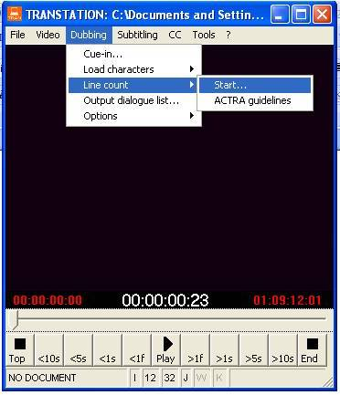

When the Line Count is done, make sure there are no duplicate names.
CAMPEONCITO: 6
CAMPEONZITO: 2
CORAZÓN VALIENTE: 6
SIN CORAZÓN: 10
SIN CORAZÓN : 2
BESTIA: 9
BESTÍA: 9
LUMINOSO: 9
CORAZÓN GOLOSO: 15
ALEGROSITA: 7
TOTAL: 66

In the above line count you can see that:

1 – Campeoncito is spelled in two different ways. You must find in the script where Campeoncito was spelled with z and change to the correct spelling (use find and replace WORD’s feature).

2 – There is a space after some of SIN CORAZÓN’s character allocation. You must find SIN CORAZÓN (space) and replace for SIN CORAZÓN without the space after the name (use find and replace WORD’s feature).

3 – Bestia is spelled with accent and without. You must replace Bestía for Bestia in the entire script (use find and replace WORD’s feature).
.
4 – Also very important: if the word Total at the end of the line count is in Upper Case, you probably forgot to eliminate formatting on the first line of the script. If the line count is correct and there are no changes to be made to any character’s name, you must select the TOTAL line and the first dialogue, then in the FONT menu, uncheck the option ALL CAPS.

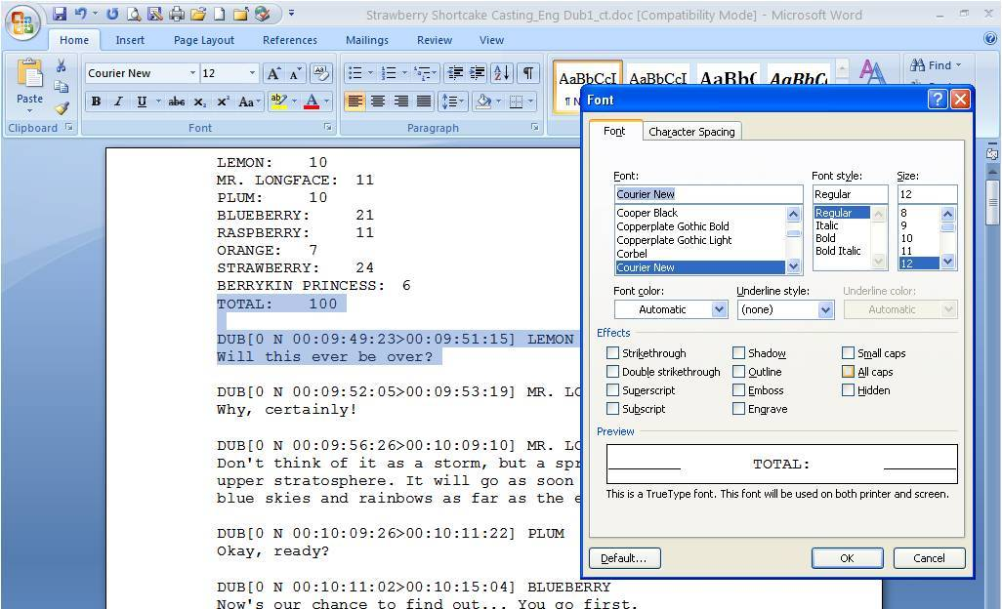
In case you need to make corrections in certain character’s names, make the corrections, delete the line count, format the first line of the scrip (see First Line Formatting) and only then run line count again.

Total should be spelled like so: T in upper case and otal in lower case.

When the line count is too long, the best way to check the characters listing is to copy the line count, open a new WORD document, paste the line count and click on the SORT icon.

Sort by PARAGRAPHS, Type TEXT should be on the sorting window. Click ok. If there are any similar names, you must do the corrections accordingly. Then, delete the Line Count and run a new Line Count. Revise the new Line Count again.

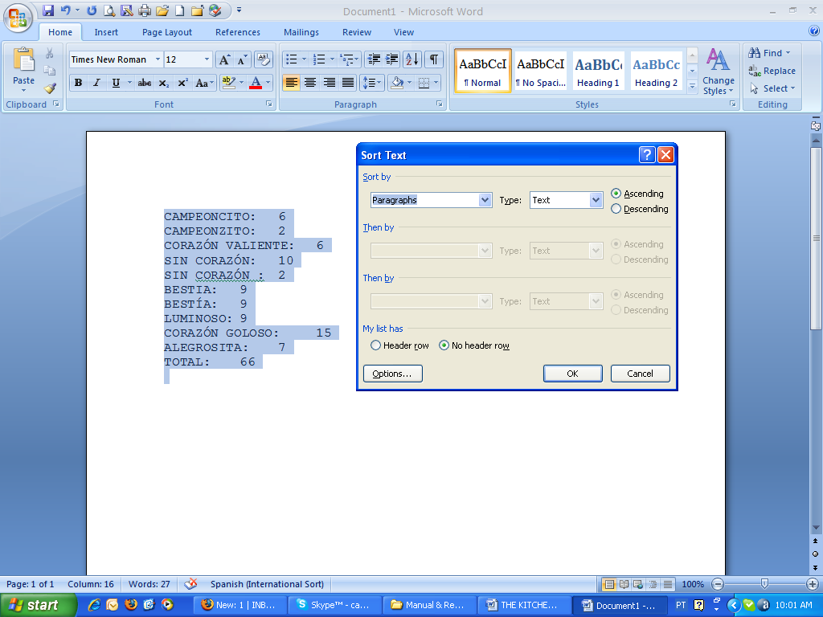

After correcting all characters’ names and the formatting of the first line, delete the old line count and run a new line count again.

Every time you run line count, you must make sure the characters’ names are correct, until there are no mistakes.

When the line count is correct, your job is done.

7 - TRANSTATION™ BASIC COMMANDS

Knowing TranStation™

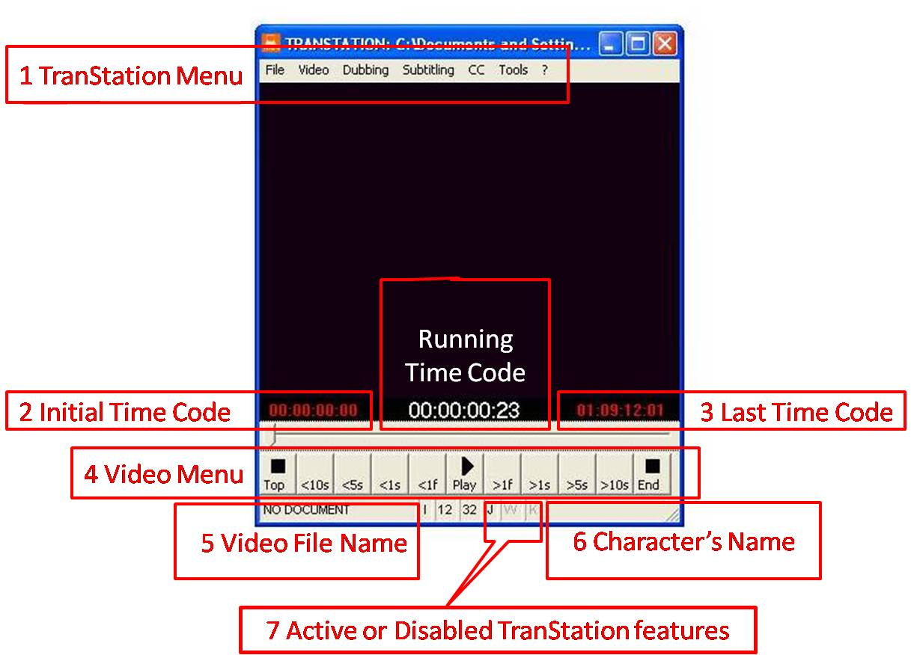

Setting up TranStation™ for Dubbing

On the TranStation™ Menu, click on Dubbing. There shouldn’t be any check marks in front of any of the items in the menu or in the drop-down menus.

This is the only setup necessary to start working in a dubbing script. To make sure nothing is checked.

Press ALT+TAB to move from WORD to TranStation™. You can see which program is active by noticing the darker color on the software top margin.

TranStation™ is the active program
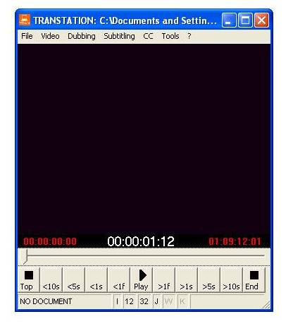

TranStation™ is not the active program
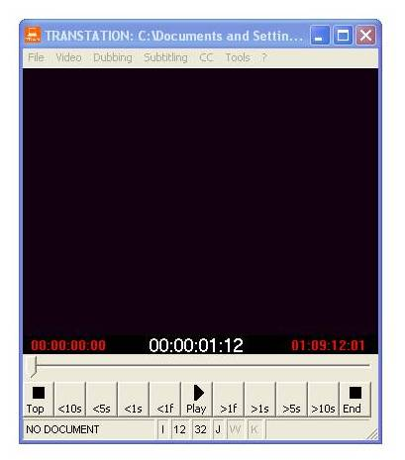

Spotting Commands – Enter/Space bar

After translating/adapting, press ALT + TAB to move from WORD to TranStation™.

Make sure the video will start running before the dialogues you’ll spot. You can rewind the video by clicking on <10s (rewind 10 seconds), <5s(rewind five seconds), <1s (rewind one second) or <1f (rewind one frame) on the Video Menu (same goes for forwarding). You can also click, hold and slide the time arrow (the one pointing down right above the Video Menu, or you can click on Play and press the arrow to the left as many times necessary until you reach the point in the video where you’ll start spotting.

When the video is at the point where you want it to be, press ENTER to run the video for spotting.

Press and release SPACE BAR to set the time code in when sound bite starts. Press and release SPACE BAR again to set the time code out when the sound bite ends.

If the next dialogue is right after the one you just spotted and you missed the cue in, do not panic! Press arrow to the left to rewind the video up to the point before the dialogue you’ll be spotting starts, then proceed to press and release space bar for time code in and again for time code out. You can rewind or fast-forward the video using the arrows as many times as you want.

If you need to stop the video, press the ESCAPE key.

Whenever you’re ready to spot again, press ENTER.

Simulation Command – Ctrl+L

After you spotted the first scene, it’s time to simulate the script along with the video.

Press ALT+TAB to move to WORD, select the dialogues you’ll simulate by clicking and dragging the mouse from the beginning of the first dialogue to the end of the last dialogue.

Press ALT+TAB to move back to TranStation™.

Press CTRL+L.

Video will run and dialogues will appear on the TranStation™ window. A blue line will run through the dialogue during the time you set for that dialogue to be read. The blue line must start running with the sound bite and stop running when the sound bite is over. Not before or after the sound bite in either cases.

To stop simulation, press ESCAPE or wait until TranStation™ reaches the last dialogue previously selected in WORD.

If you are revising the entire script, in WORD put the cursor in front of the first dialogue, press CTRL+A to select the entire script, press ALT+TAB to move to TranStation™, press CTRL+L to simulate. To stop press ESCAPE.

To simulate from the point you stopped on, in WORD put the cursor in front of the dialogue you want to re-start from, press CTRL+SHIFT+END to select the dialogues, press ALT+TAB to move to TranStation™, press CTRL+L to continue simulating from that point on.

You can always stop both spotting and simulation by pressing ESCAPE. During the reviewing process, while you’re simulating, you can stop the video, go to WORD, adjust timing or correct text, and then go back to simulating.

For one last revision ONLY, you can press CTRL+J (letter J will be active on the TranStation™ window, on the bottom middle of the window – see picture above) to make sure you simulate all dialogues, even the ones overlapping or with the same time codes.

But if you have the Jump feature (J) active while working on the script, you might not see that there is a sound bite with no dialogue assigned to it, as the feature Jump will actually jump from one dialogue to the next, and whatever is in between will be skipped. Pay close attention to this.

For more detailed commands refer to the TranStation™ Manual.

This Manual was created for training and consulting purposes by the translators testing or working with The Kitchen. Copy of this material for commercial purposes is illegal and punishable by law.

